5. Vascular Fluids: Composition and Function *Ch 44, 46*

______________________________________________________________________________

I. Introduction

A. Functions of Circulatory Systems

B. Body Fluids

II. Composition of Blood *(1035-1038)*

A. Plasma

1. Water content

2. Solutes

B. Cell Types

1. Erythrocytes

2. Leukocytes

3. Platelets

III. Oxygen Transport by Blood *(1083-1089)*

A. Efficiency of Oxygen Delivery

B. Respiratory Pigments

1. Diversity of pigments

2. General function

3. Packaging of pigments

4. Oxygen loading and unloading

C. Functioning of Respiratory Pigments

1. Partial pressure of a gas

2. Oxygen dissociation curves

3. Factors affecting dissociation curves

4. Storage pigments

D. Special Adaptations for Low Oxygen Availability

1. Diving

2. High altitudes

IV. Carbon Dioxide Elimination *(1085-1086)*

A. The Problem of Acidosis

1. Carbonic acid and bicarbonate ions

2. Buffering of blood

B. Elimination of Waste at Respiratory Surface

05-1

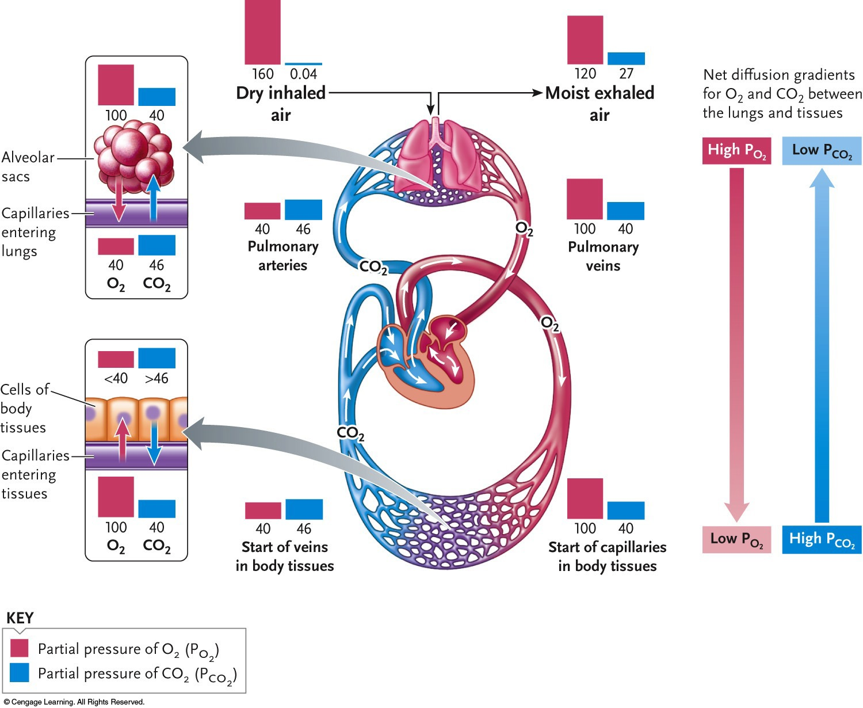

05-2

